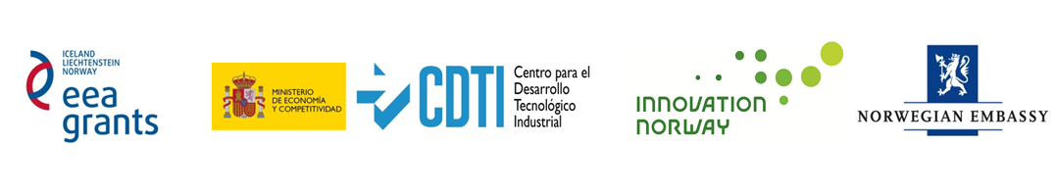
Promoting the bilateral cooperation
through the EEA Grants 2009-2014
Expert Seminar on Policy Making and R&D in Energy Efficiency
Madrid, October 22nd 2014
Registration Form
Name of Company: _______________________________________________________________
Web page: ______________________________________________________________________
Participant: ______________________________________________________________________
Phone number: __________________________ E-mail: _____________________________
Passport number:_____________________________________
Date of arrival____________________ Date of departure__________________________

Brief description of the company:____________________________________________________
________________________________________________________________________________
________________________________________________________________________________
R&D and/or commercial prospects or on-going projects:__________________________________
________________________________________________________________________________
________________________________________________________________________________
Interest on B2B meetings _______
Please provide a short profile of a desirable R&D or commercial partner ____________________
_________________________________________________________________________________
_________________________________________________________________________________
_________________________________________________________________________________

Please respond before October 3rd to: rodrigo.ballesteros@innovationnorway.no
Telephone: +34 91 344 13 37

